* **Infra failed error came on Slack. Click on this link and login Newrelic and acknowledge the error.**

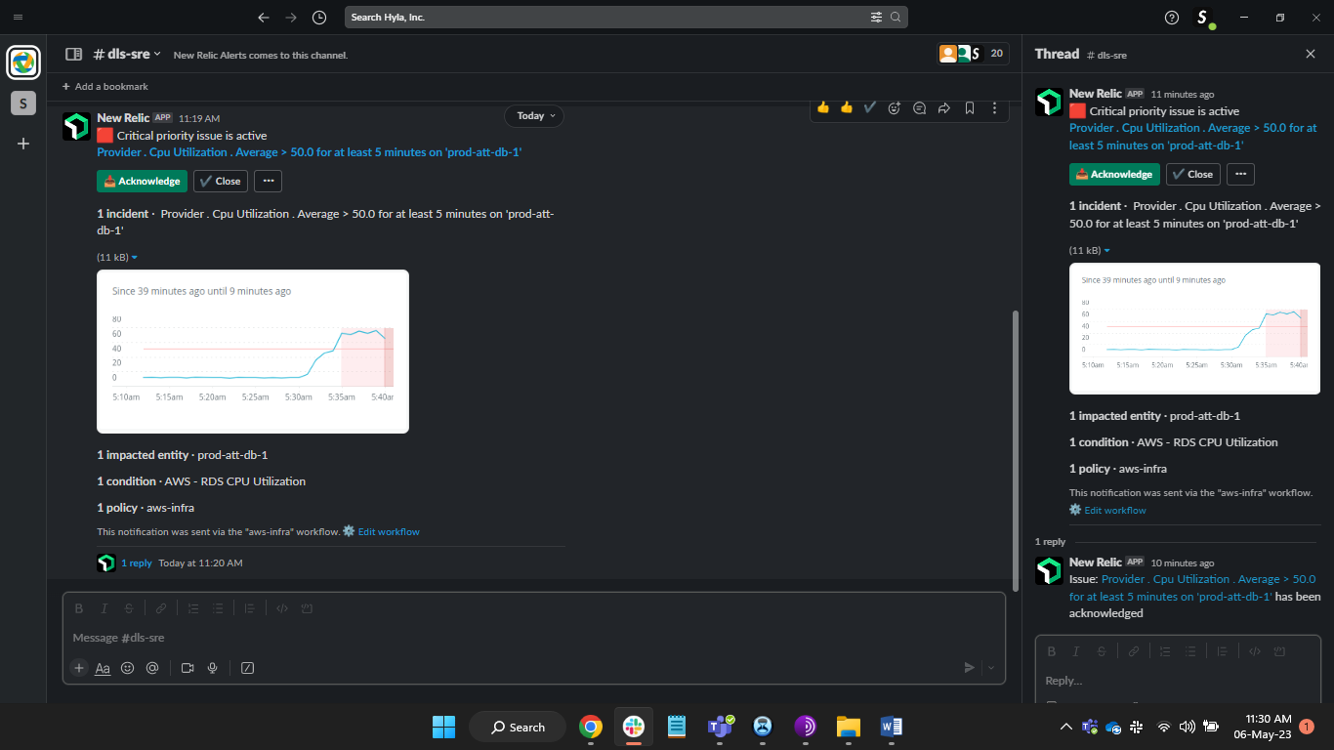

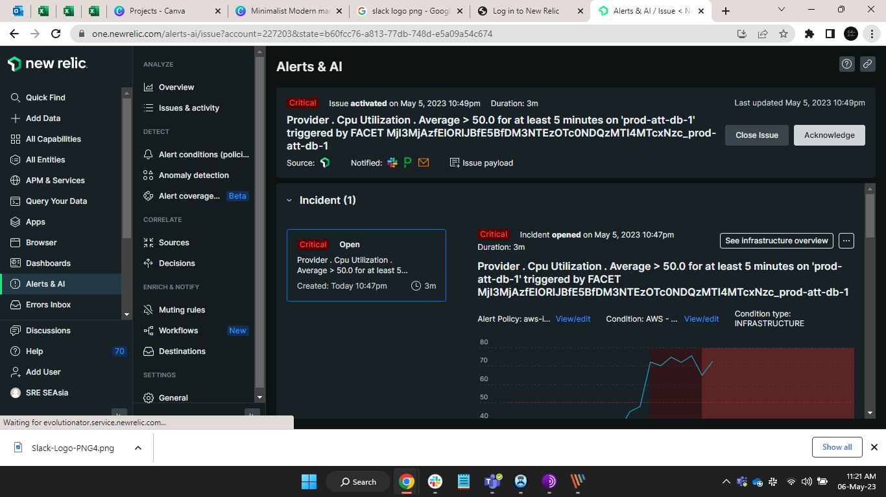

* **After acknowledge Infra error show on Slack and Newrelic site like this.**

# 

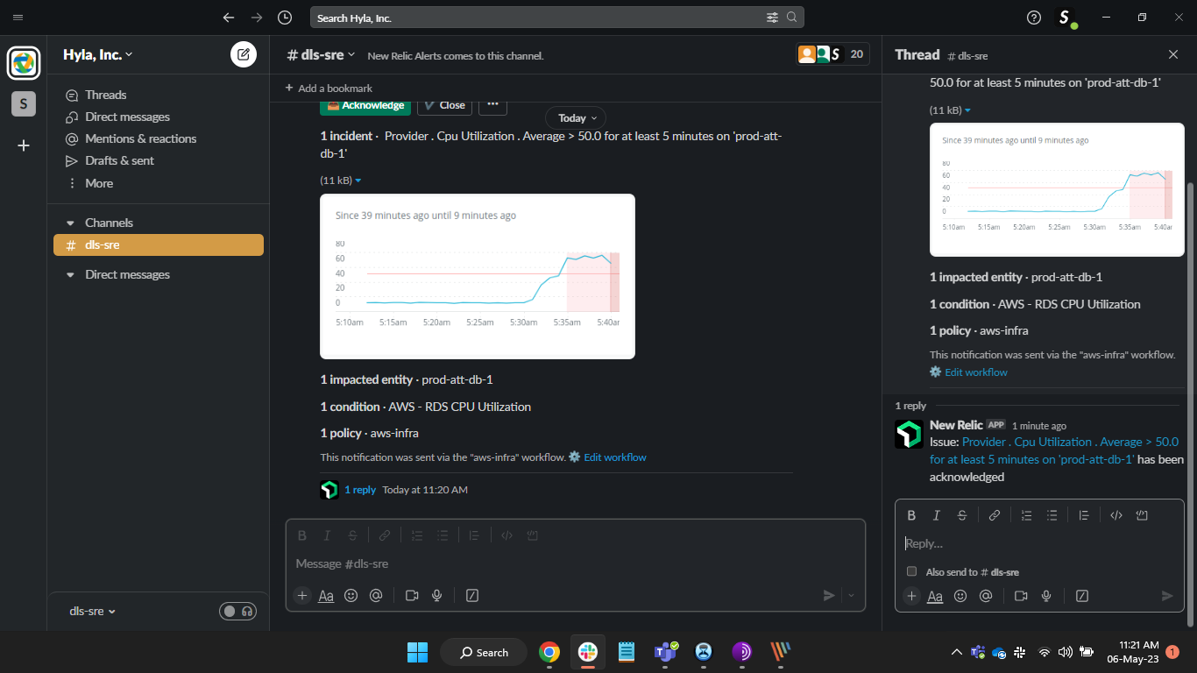

* **This infra error also show in PagerDuty.**

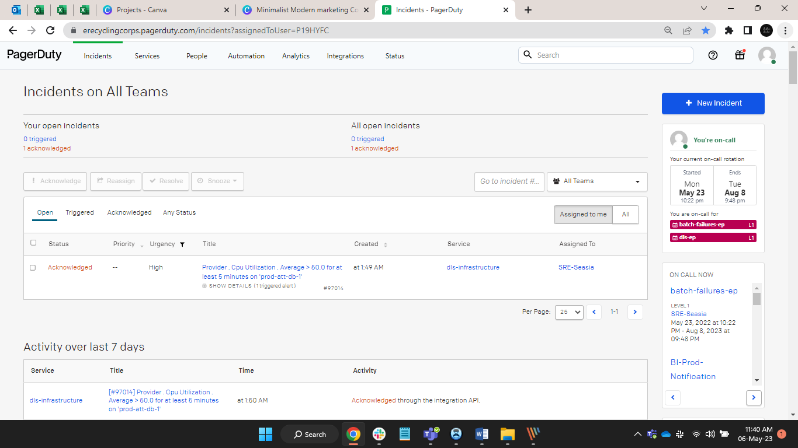

* **This infra error logs in PagerDuty.**

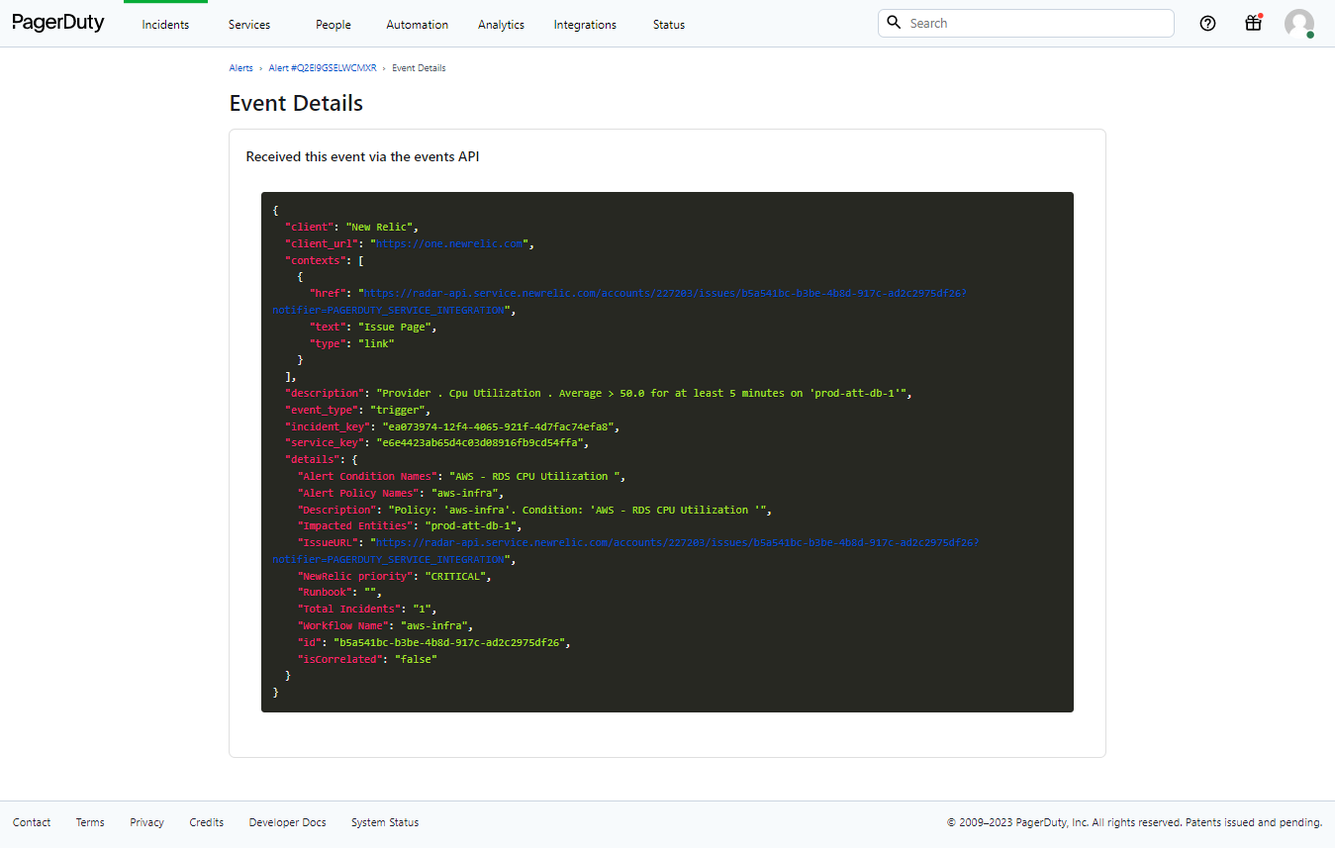

* **When Error Closed its show like this on Slack.**

